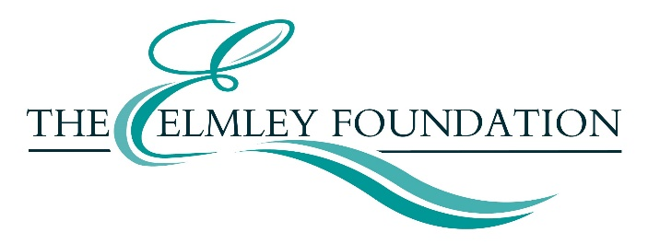

My Place: Reference
Grants of up to £2,000 for communities to commission new artwork or arts activity in Herefordshire. A joint funding scheme from the Elmley Foundation and Herefordshire’s A Great Place project.
FOR OFFICE USE ONLY:
DATE SUBMITTED
REFERENCE NUMBER

Name of organisation applying for grant

The following section should be completed by your independent referee
Name:

Address:
Postcode:

Email:
Telephone:

How do you know the organisation/group:

Signed:
Date:

